**Performance Assessment**

**NBM3 TASK 1: LINEAR REGRESSION MODELING**

Bader Ale

Department of Information Technology, Western Governors University

D208 Exploratory Data Analysis

Professor William Sewell

July 2023

Table of Contents

Part I: Research Question 3

Part II: Method Justification 3

Part III: Data Preparation 4

Univariate Visualizations 5

Bivariate Visualizations 7

Part IV: Model Comparison and Analysis 9

Initial Regression Model 9

Works Cited 11

# Part I: Research Question

For this performance assessment, my research question is: **Does either age, income, doctor visits, and days spent in the hospital, which caused a greater increase in the total charge to the patient**. This will help determine which of these factors are the biggest influence of a patient’s total charge during their stay. The goal is to help patients determine what has the biggest influence on their hospital charges.

# Part II: Method Justification

For this performance assessment, we will be using multivariate linear regression to determine the relationship between our explanatory variables and our target variable. In order to do this, we must first take into account certain assumptions. First of all, there has to exist a linear relationship between each of the explanatory variables (independent variables, X) and the target variable (dependent variable, Y). Secondly, we must determine if no multicollinearity exists between the explanatory variables. This is because the linear model will not be great if more than one variable affects the independent variable the same way. Thirdly, all explanatory variables must be independent of each other. Lastly, the residuals of the model should have a constant variance, or deviation from the true value, at every point in the model (Zach, 2021).

Python was chosen over R for two reasons. The first reason is the existing familiarity with Python; the only thing to learn was which libraries needed to be imported and the parameters. Even though R was writes specifically for statistical analysis and Python as more of a general programming language, many libraries have been created for Python to perform like R. The second reason is its flexibility and ease of reading/structuring.

Multiple linear regression (MLR) is the appropriate technique for analyzing the research question because we effectively want to predict a total charged to the patient depending on several other, independent factors. Multiple linear regression, or multivariate linear regression was used in lieu of regular, univariate linear regression because of the multiple explanatory variables considered.

# Part III: Data Preparation

In order to begin running the regression model, the data had to be cleaned and pre-processed. This reduces the model’s error and allows for seamless splitting of the data for both x-and y- values. The data preparation included replacing missing values, if any, Furthermore, checking for any duplicated values that could interfere with our model. Lastly, outliers were dealt with accordingly, ensuring that the values used for the model were accurate and within an acceptable range.

The following table shows the independent and dependent variables used in regression model as well as the output of the summary statistics for each. Visualizations have also been included for both univariate and bivariate.

Table 1: Variables used in Model.

|  |  |
| --- | --- |
| **Dependent Variables** | **Independent Variables** |
| Age | TotalCharge |
| Income |  |
| Doc_visits |  |
| Initial_days |  |

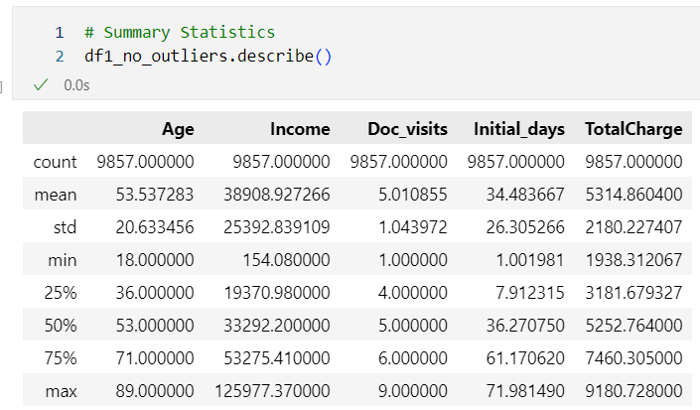

Figure 1:Variable Summary Statistics

## Univariate Visualizations

## Bivariate Visualizations

The goal for transforming the data is to prepare it in a way that is easy for the model to use and that minimizes error. Also, some libraries used in the regression modeling, for example Statsmodel, require the data to be “packaged” in a certain way for the code to run.

# Part IV: Model Comparison and Analysis

## Initial Regression Model

An initial multivariate regression model was created using the prepared dataframe containing all the independent variables(shown inTable 1: Variables used in Model.**).** We first had to define the X (independent variables) and Y (TotalCharge). The code snippet is shown below for this process:

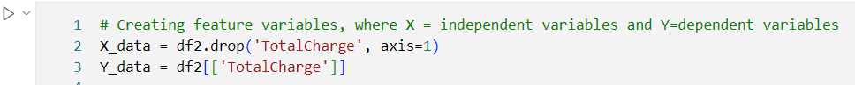

Figure 2: X and Y variable assignments

Confirming we defined the variables correctly we output the head of both variable assignments:

Figure 3: Printing X and Y shape/head

Here we can see that the code prints out a message showing the shape and head of the dataframes of both the X and Y respectively. After adding a constant using .*add_constant()* attribute of the OLS module, the linear regression object was created with the additional *.fit()* command, as shown below.

Figure 4: Regression Model parameters

The following shows the summary display of the initial regression model.

Figure 5: Summary of Initial Regression Model

Here we can see our four dependent, explanatory variables, their standard errors, and the p-values. Of these, we can see that *Initial_days* had a p-value of one,

# Works Cited

Zach. (2021, November 16). *The Five Assumptions of Multiple Linear Regression*. Retrieved July 3, 2023, from Statology: https://www.statology.org/multiple-linear-regression-assumptions/